How to Log into Your Team Page

Each team has a page. From the home page of the League Website, click on 2020 Teams:
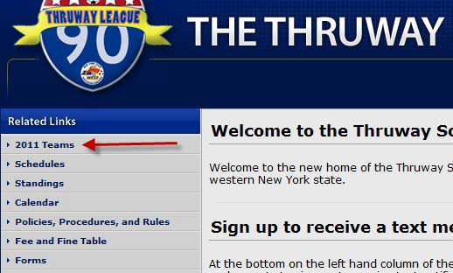
The next screen will show you team names, ordered by divisions. Go to your division, find your team name and click on it:
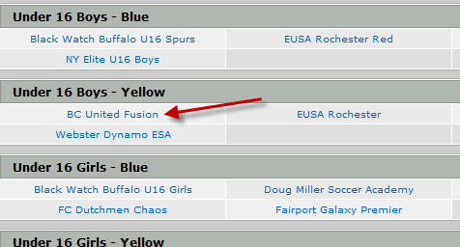

On the next screen you will find your spot to log in on the upper right-hand side.
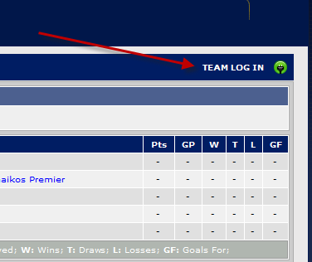

The next screen will ask for your log in information. Use your e‐mail address. If you do not know the pin number, click on the link to have it sent to you.
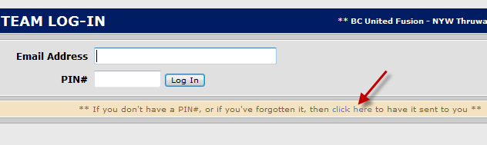

After you get logged in the first screen will look like this:
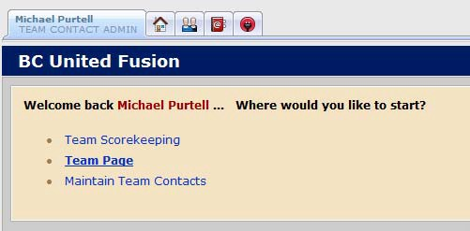
Team Scorekeeping should be self-explanatory; this is where you go to enter your match scores after a game. If you have any outstanding games that you have not input the score for, they will be listed here. Remember, both teams need to input the score and they must agree before the standings will update. All scores need to be entered no later than 9PM each Monday. Late score reporting will cost you
$10.00.

Team Page will take you to the page that is normally public on the website. This is where you go each week to get copies of your roster to take to games. Click on your official schedule.
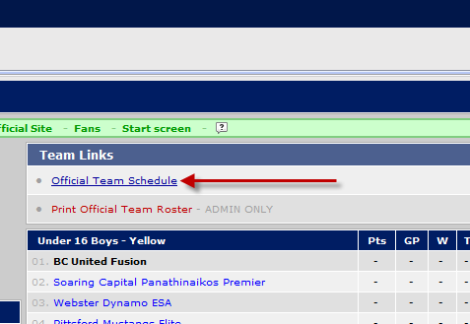
Your schedule will open towards the bottom of the page.

Find your upcoming match on the schedule. Notice that the ‘vs.’ is a link in the match report column. Please click on this.
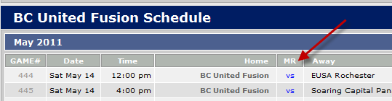

The next screen will give show you the information about the match across the top as well as show you both your roster and the opponents roster. Below the rosters will be a list of any player who is ineligible or suspended for the match. Use your browser print function to print two copies to take to the match.

Maintain Team Contacts lets you add or delete who your contacts are, set whether or not they have log in access to the team page. You also have the opportunity in your record to change the pin number to something you can more easily recall.

